CUSTOMER DATA ANALYSIS PROJECT MySQL Queries

1. How is the shopping distribution according to gender?
SELECT gender,COUNT(*) AS total_shoppings
FROM customer
GROUP BY gender;
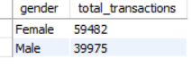

2. Which gender did we sell more products to?
SELECT gender, SUM(quantity) AS total_products_sold
FROM customer
GROUP BY gender;
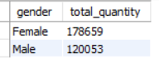

3. Which gender generated more revenue?
SELECT gender, SUM(quantity * price) AS total_revenue
FROM customer
GROUP BY gender;
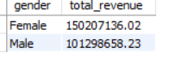

4.Distribution of purchase categories relative to other columns?
-- (You need overall category distribution)
SELECT category, COUNT(*) AS total_transactions
FROM customer
GROUP BY category;

-- ✔ Plus category vs gender, age if needed:
SELECT category, gender, COUNT(*)
FROM customer
GROUP BY category, gender;

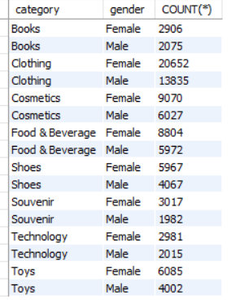

5. How is the shopping distribution according to age?
SELECT
CASE
WHEN age BETWEEN 18 AND 25 THEN '18-25'
WHEN age BETWEEN 26 AND 35 THEN '26-35'
WHEN age BETWEEN 36 AND 45 THEN '36-45'
WHEN age BETWEEN 46 AND 55 THEN '46-55'
ELSE '56+'
END AS age_group,
COUNT(*) AS total_transactions
FROM customer
GROUP BY age_group;
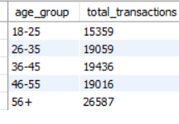

6. Which age category did we sell more products to?
SELECT
CASE
WHEN age BETWEEN 18 AND 25 THEN '18-25'
WHEN age BETWEEN 26 AND 35 THEN '26-35'
WHEN age BETWEEN 36 AND 45 THEN '36-45'
WHEN age BETWEEN 46 AND 55 THEN '46-55'
ELSE '56+'
END AS age_group,
SUM(quantity) AS total_quantity
FROM customer
GROUP BY age_group;
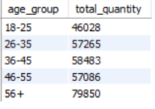

7. Which age category generated more revenue?
SELECT
CASE
WHEN age BETWEEN 18 AND 25 THEN '18-25'
WHEN age BETWEEN 26 AND 35 THEN '26-35'
WHEN age BETWEEN 36 AND 45 THEN '36-45'
WHEN age BETWEEN 46 AND 55 THEN '46-55'
ELSE '56+'
END AS age_group,
SUM(quantity*price) AS total_quantity
FROM customer
GROUP BY age_group;
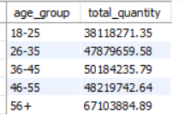

8. Distribution of categories relative to other columns?
-- (You can repeat category vs age, vs gender, vs payment method)
SELECT category, gender, COUNT(*)
FROM customer
GROUP BY category, gender;

9. Does the payment method have any relation with other columns?
-- ✔ Use:
SELECT payment_method, gender, COUNT(*)
FROM customer
GROUP BY payment_method, gender;

-- ✔ And:
SELECT
CASE
WHEN age BETWEEN 18 AND 25 THEN '18-25'
WHEN age BETWEEN 26 AND 35 THEN '26-35'
WHEN age BETWEEN 36 AND 45 THEN '36-45'
WHEN age BETWEEN 46 AND 55 THEN '46-55'
ELSE '56+'
END AS age_group,
payment_method,
COUNT(*) AS total_transactions
FROM customer
GROUP BY age_group, payment_method;

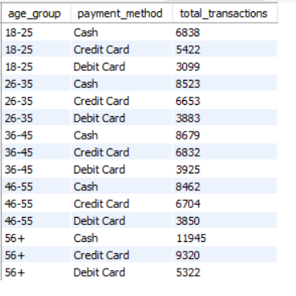

10. How is the distribution of the payment method?
-- ✔ Use:
SELECT payment_method,gender, COUNT(*) AS total_transactions
FROM customer
GROUP BY payment_method, gender
ORDER BY payment_method, gender;
